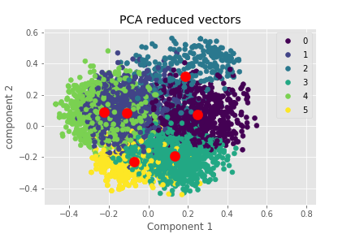**PCA:  Data Scientist and Statisticians are Neighbors**

Software Engineer Data Analyst Statistician

Data Scientist Data Engineer Database Administrator



Data Analyst

Data Scientist

Software Engineer

Statistician

Data Engineer

Database Administrator